18.29:
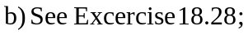

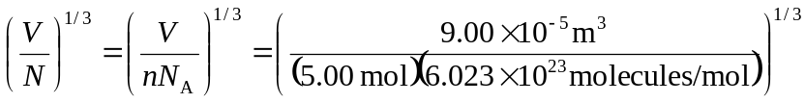
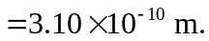

c) This is comparable to the size of a water molecule.

